CentOS Server
AI used : Gemini by Google
Prompt used : Make a script for cybersecurity on CentOS
I just make one attempt and try it.
Even do the script show it completed there’s some typo error in it.

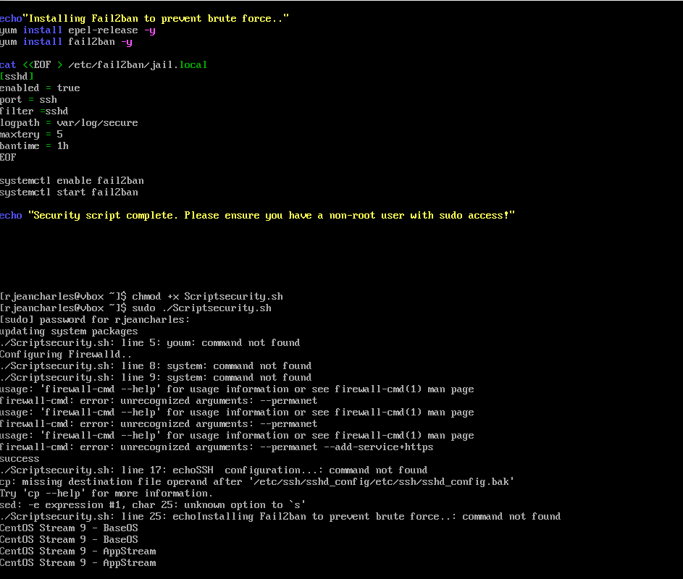
Command use : chmod +x Scriptsecurirty.sh
Sudo ./Scriptsecurity.sh

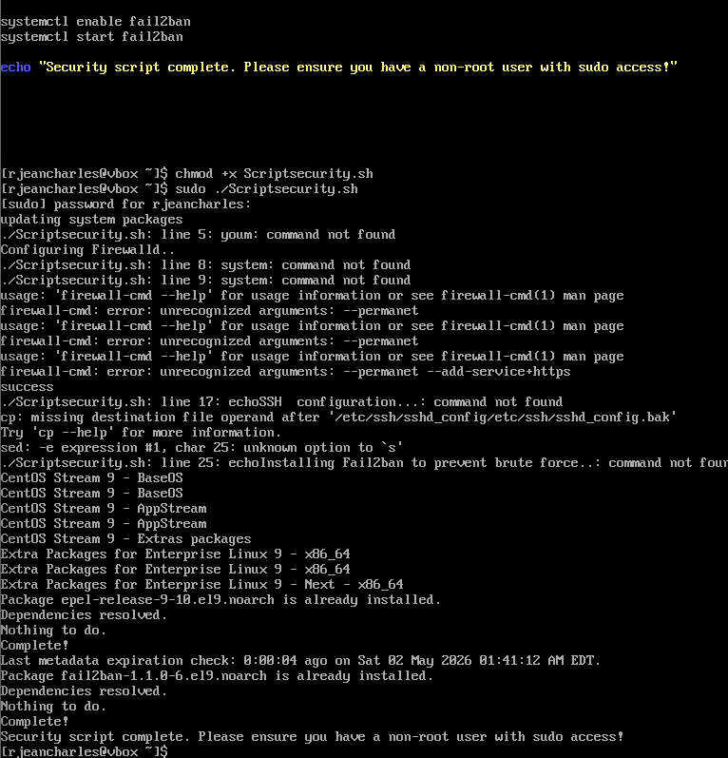

The process is completed. Which means it worked very well
I don’t have to modify anything in the script provided by Gemini

AI conversation summary including the script with add and comments
make a security script for CentOS server
Securing a CentOS server (or its successors like Rocky Linux and AlmaLinux) involves layering defenses. This script focuses on the essential "First 10 Minutes" of server hardening: updating the system, configuring a firewall, and tightening SSH access.
🛡️ CentOS Hardening Script
Save this code as harden.sh, give it execution permissions with chmod +x harden.sh, and run it as root.
Bash
#!/bin/bash

# --- 1. Update System ---
echo "Updating system packages..."
yum update -y && yum upgrade -y

# --- 2. Configure Firewall (Firewalld) ---
echo "Configuring Firewalld..."
systemctl start firewalld
systemctl enable firewalld

# Allow SSH and standard web traffic
firewall-cmd --permanent --add-service=ssh
firewall-cmd --permanent --add-service=http
firewall-cmd --permanent --add-service=https

# Reload to apply changes
firewall-cmd --reload

# --- 3. SSH Hardening ---
echo "Hardening SSH configuration..."
cp /etc/ssh/sshd_config /etc/ssh/sshd_config.bak

# Disable Root Login over SSH
sed -i 's/#PermitRootLogin yes/PermitRootLogin no/' /etc/ssh/sshd_config
sed -i 's/PermitRootLogin yes/PermitRootLogin no/' /etc/ssh/sshd_config

# Disable Password Authentication (Optional: Only if using SSH Keys)
# sed -i 's/PasswordAuthentication yes/PasswordAuthentication no/' /etc/ssh/sshd_config

systemctl restart sshd

# --- 4. Install & Configure Fail2Ban ---
echo "Installing Fail2Ban to prevent brute force..."
yum install epel-release -y
yum install fail2ban -y

# Enable Fail2Ban for SSH
cat <<EOF > /etc/fail2ban/jail.local
[sshd]
enabled = true
port = ssh
filter = sshd
logpath = /var/log/secure
maxretry = 5
bantime = 1h
EOF

systemctl enable fail2ban
systemctl start fail2ban

# --- 5. Clean up ---
echo "Security script complete. Please ensure you have a non-root user with sudo access!"

🔑 Critical Next Steps
Running a script is a great start, but manual oversight is required for a truly secure environment.
- Create a Sudo User: Since the script disables direct Root Login for SSH, you must have a user account with sudo privileges, or you will lock yourself out.
- SSH Key Authentication: Instead of passwords, use RSA or Ed25519 keys. They are nearly impossible to brute-force.
- SELinux: Ensure SELinux is set to Enforcing mode. Check this by running sestatus.
- Audit Logs: Regularly check /var/log/secure to see who has been attempting to access your server.
Comparison of Security Tools
Tool | Purpose | Benefit
Firewalld | Network Filtering | Blocks all ports except those explicitly allowed.
Fail2Ban | Intrusion Prevention | Automatically bans IPs that show malicious signs (like 5 wrong passwords).
SELinux | Mandatory Access Control | Limits what processes can do, even if they are compromised.
Rootkit Hunter | Malware Scanning | Scans for hidden "rootkits" and backdoors in the file system.

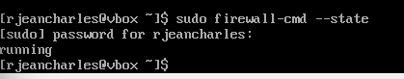
Firewall tested
Command use : sudo firewall-cmd –state

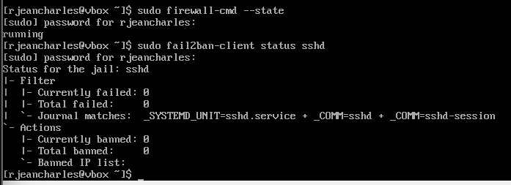
Fail2ban tested
Command used : sudo fail2ban-client status sshd

However, I had to correct the typo error youm to yum
I used chmod +x security and sudo ./Scritsecurity.sh
I got this processing
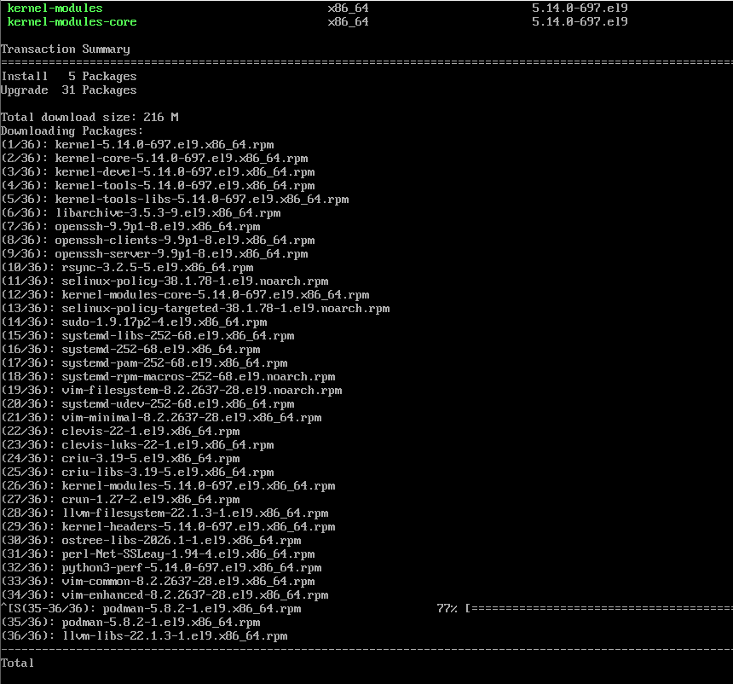

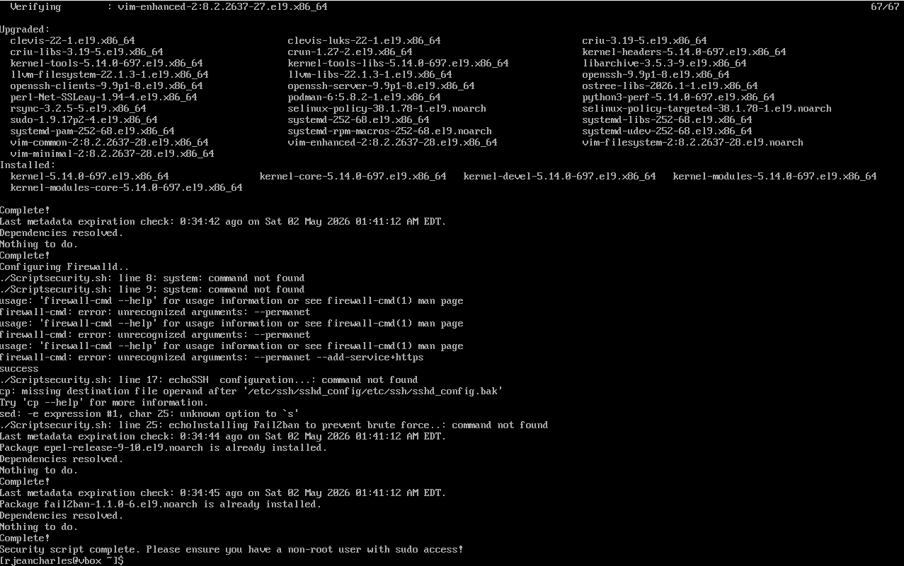

Right now, the script is completed this time without errors output

